CLACKAMAS LITTLE LEAGUE
12TH ANNUAL DON WYLER INVITATIONAL BASEBALL TOURNAMENT – MAY 20-22, 2022
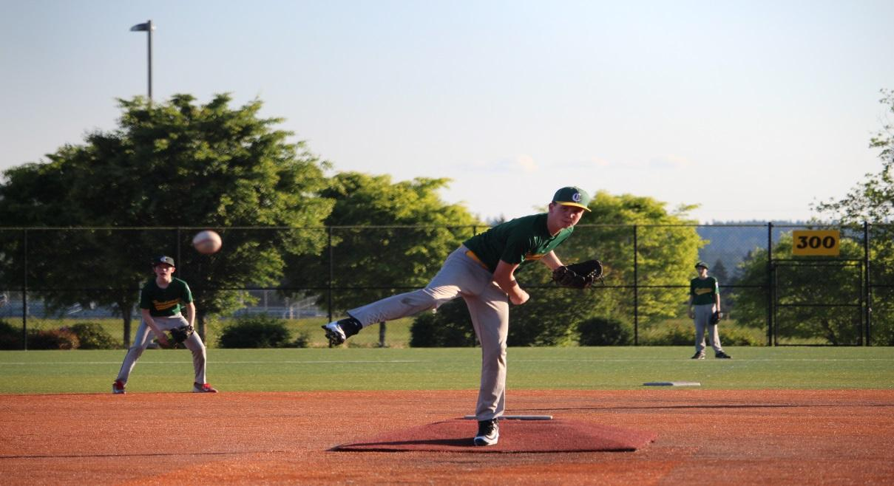
- FEATURES GAMES AT HOODVIEW PARK SPORTS COMPLEX - ALL WEATHER TURF FIELDS - LOCATED IN OREGON DISTRICT 2, JUST SOUTH OF PORTLAND IN HAPPY VALLEY, OREGON.
- MAJORS DIVISION BASEBALL TOURNAMENT ONLY. 4 GAMES GUARANTEED (POTENTIALLY 1 FRIDAY GAME, 1 OR 2 SATURDAY GAMES & 2 SUNDAY GAMES)
- REGULAR SEASON ONLY TEAMS! NO ALL-STARS TEAMS. UP TO 2 POOL PLAYERS PER TEAM. POOL PLAYERS MUST BE ASSIGNED BY PLAYER AGENT PER LL RULES AND COMMUNICATED PRIOR TO TOURNEY W/ CLL PLAYER AGENT AND TOURNEY DIRECTOR.
- EMAIL FORM BELOW TO INFO@CLACKAMASLITTLELEAGUE.ORG.
- MAIL CHECK AND COMPLETED FORM TO CLACKAMAS LITTLE LEAGUE, PO BOX 52, CLACKAMAS, OR 97015. *VENMO ACCEPTED
- LEAGUE, ID# & DISTRICT:
- CONTACT:
- EMAIL: PHONE:
ENTRY FEE IS $325/TEAM + 1 DOZEN LITTLE LEAGUE GAME BALLS FOR YOUR DIVISION

